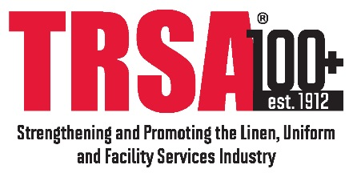

AGENDA
Industrial/Uniform Committee
Sheraton Pentagon City, Arlington, VA
March 22, 2018

- Welcome and Introduction

- Minutes of September 12, 2017 Teleconference

- Committee Mission/Objectives/Webpage

- Review of February 2018 Webinar

- Industrial-Only Professional Development/Education
- Webinars
- Breakout Sessions
- Adjunct to Production Summit
- Separate Event (Roundtable/Tours)
- Magazine/Website Editorial Content

- Hygienically Clean Food Safety Certification Update

- Recruiting
- Industrial/Uniform TRSA Prospects
- Industrial/Uniform Committee Prospects

- New Business

- Next Meeting
- Schedule teleconference for June
- TRSA Annual Conference & Exchange, Oct. 15-17, Napa, CA

