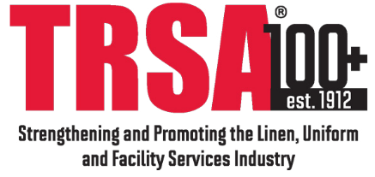

#TODAY#

Dear #CONGRESSMAN#,

TRSA – The Linen, Uniform and Facility Services Association members from your #REGION# will be participating in a Virtual Advocacy Day on March 25th, 2021 and would like to take the opportunity to meet with you over the phone and/or video. The #PL_CONSTITUENT# from your #REGION# who will be participating in the meeting #PL_IS#:

#CONSTITUENTS#

We hope you would be available to meet sometime between 9:00 am and 5:00 pm on Thursday, March 25th. We have a free conference line and/or video platform that we are able to provide for this meeting.

TRSA members would like to meet with you to discuss the importance the importance the industry plays in strengthening supply chain issues with healthcare linens and critical personal protection equipment (PPE), the role the industry plays in maintaining safety after any type of disaster and the positive environmental stewardship the industry provides.

TRSA represents the linen, uniform and facility services industry. TRSA members are commercial laundry/ facility services companies and their supplier partners who manufacture and supply their needed supplies and infrastructure. Both of these sectors of our membership enable life-sustaining businesses to safely operate. These include healthcare facilities, grocery stores, infrastructure maintenance, food processing, public utilities (water and energy), first-responders, federal and state governments, laboratories, pharmaceutical manufacturing, and other fundamental supply chain businesses. Essential workers and the public depend on our industry to produce and process PPE including healthcare contact textiles (HCTs), flame-resistant and high visibility clothing, first aid and safety items and other protective garments.

These individuals play an important role in creating and sustaining the great communities in your state. Although we understand your busy schedule, we hope you can spare a few minutes to talk with them about ways in which the federal government can improve and enhance its partnership with these individuals and the communities they represent. If you are unavailable, we hope your staff handling healthcare supply chain and disaster recovery issues would be able to meet with them.

Thank you for attention in this matter. To set up a meeting please contact Austin Mix, the TRSA scheduling staff person, at (202) 964-0395 or trsa.scheduler@gmail.com. We will contact you in the next few days to see what may be possible.

Sincerely,

TRSA Scheduling Team

